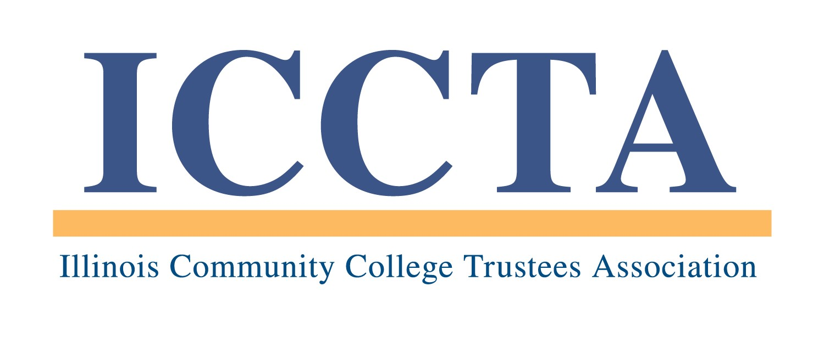

2020 BUSINESS / INDUSTRY PARTNERSHIP AWARD

The Illinois Community College Trustees Association's Business / Industry Partnership Award recognizes an Illinois business that has built a successful workforce-training alliance with a local community college.

AWARD CRITERIA
Each nomination for the ICCTA Business / Industry Partnership Award will be reviewed according to the following criteria:
▪ History, goals and uniqueness of the partnership
▪ Examples of innovative curricula, training programs, and/or academic courses developed
▪ How the business is involved in planning, reviewing and evaluating the college’s curricula and workforce training programs
▪ How the business supports and promotes the college’s workforce training efforts
▪ Ways in which the business serves and supports the college constituency
▪ Measurable improvement rates (e.g., productivity increases, cost decreases, expansion of services or product)
▪ Employment and promotion opportunities for community college alumni
▪ How the business and college have benefited from the partnership
▪ Gains realized by the community
▪ Other noteworthy results

NOMINATION REQUIREMENTS
Nominations for the ICCTA Business / Industry Partnership Award must be submitted by the board of trustees of an ICCTA member college. Each ICCTA member college is eligible to nominate one business / industry partner each year. Currently serving trustees and presidents are not eligible for nomination. Posthumous nominations are not eligible for submission.

In order for a nomination to be considered, all of the following items must be included in the nomination packet. The total length must not exceed six (6) single-sided pages:
▪ Letter of support from the college board of trustees
▪ Letter of acknowledgment from the CEO of the nominated business
▪ Responses to each award criteria question
▪ Optional supplemental materials (i.e., resumé, news articles, brochures, photos)

In addition, the nomination must include a narrative statement (not to exceed 150 words) that explains the nominee’s qualifications and is suitable for use in ICCTA publicity materials. The narrative statement is not included in the 6-page nomination packet, but it is required for a nomination to be considered.

★ Failure to follow these guidelines will result in the disqualification of a nomination ★

Because the names of many deserving nominees are received each year, boards of trustees are encouraged to re-submit the names and qualifications of former nominees for consideration.

PROGRAM DEADLINES
All nomination materials must be received by 5 PM, Friday, April 3, 2020. THIS DEADLINE WILL BE STRICTLY ENFORCED. All award nominees will be invited to attend ICCTA's June 5, 2020 awards banquet in Chicago, where the statewide winner will be announced.

All nominations and support materials should be sent to the Illinois Community College Trustees Association, 401 E. Capitol, Suite 200, Springfield, IL 62701-1711. For more information, please contact Kim Villanueva at kvillanueva@communitycolleges.org or 1-800-454-2282.

2020 ICCTA Business / Industry Partnership Award
Nomination Form

Name of business / industry nominee
Contact person
Title/position
Nominee’s mailing address
Telephone # E-mail address

Name of nominator
Community college
Title/position
Nominator’s mailing address
Telephone # E-mail address

To ensure that your awards nomination is processed without delay, please check off the following items before submitting this information:

Nominations Packet -- NO MORE THAN SIX (6) SINGLE-SIDED PAGES may be submitted:
□ Letter of support from the college board of trustees
□ Letter of acknowledgment from the CEO of the nominated business
□ Responses to each award criteria question
□ Optional supplemental materials (i.e., resumé, news articles, brochures, photos)

Also required for consideration (but not included in the 6-page limit):
□ Narrative statement of no more than 150 words
□ Completed nomination form

This nomination form and supporting materials must be received by 5 PM, Friday, April 3, 2020, at the:

Illinois Community College Trustees Association
401 E. Capitol, Suite 200
Springfield, IL 62701-1711
E-MAIL: iccta@communitycolleges.org

▪ For more information, contact Kim Villanueva at kvillanueva@communitycolleges.org or 1-800-454-2282 ▪

