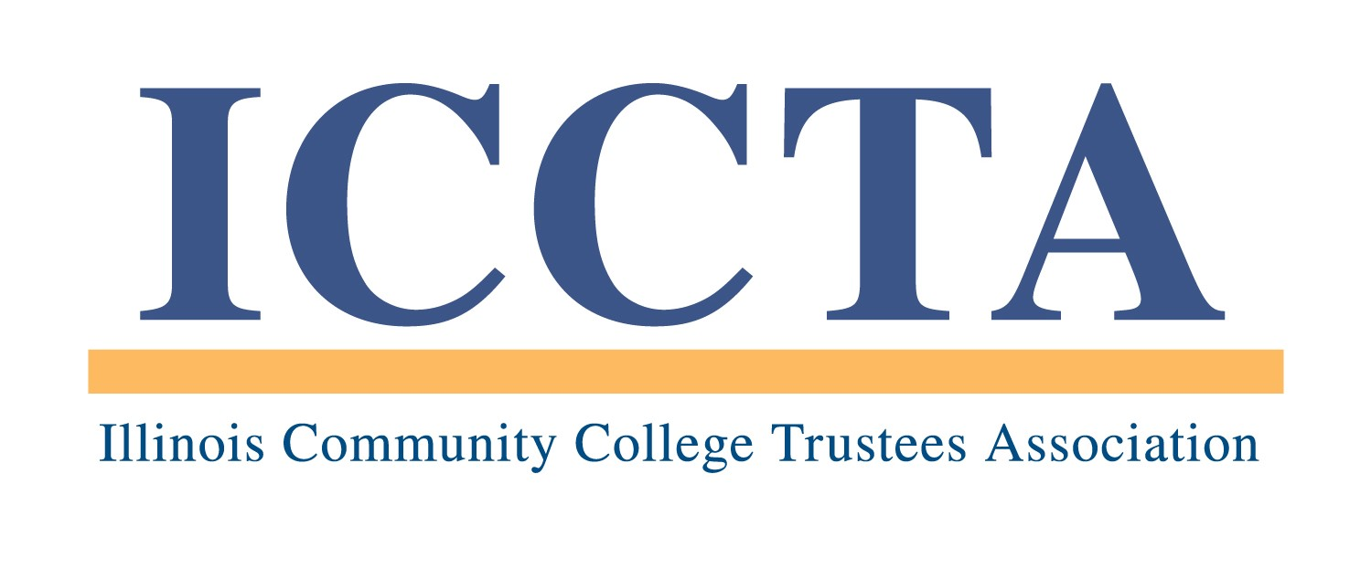

2020 PAUL SIMON STUDENT ESSAY CONTEST

The Illinois Community College Trustees Association's Paul Simon Student Essay Contest provides a $500 scholarship to the student who best describes "How My Community College Has Changed My Life."

CONTEST RULES
All currently enrolled students at ICCTA member colleges are eligible to participate in the Paul Simon Student Essay Contest at the local level. However, each ICCTA member college may enter only ONE student essay in the statewide competition each year.

Each essay must be brief (less than 500 words), typed, and address the theme "How My Community College Has Changed My Life." Entrants may use “How My Community College Has Changed My Life” as the essay’s title or create their own title related to the theme.

EACH ENTRY WILL BE JUDGED ON THE BASIS OF WRITING STYLE, CLARITY OF EXPRESSION, AND RELEVANCY TO THE TOPIC, WITH SPECIAL EMPHASIS PLACED ON CORRECT GRAMMAR AND PUNCTUATION.

★ Failure to follow these rules will result in the disqualification of an essay ★

CONTEST DEADLINES
All essays must be received by 5 PM, Friday, April 3, 2020. The winner of the Paul Simon Student Essay Contest will receive a $500 cash stipend for educational expenses during the fall 2020 semester. In addition, ICCTA will invite the winner to attend the association's June 5, 2020 awards banquet in Chicago.

To submit an entry for the Paul Simon Student Essay Contest, please send your essay and a completed Entry Form (signed by the designated contact person at your college) to:

Illinois Community College Trustees Association
401 E. Capitol, Suite 200
Springfield, IL 62701-1711
E-MAIL: iccta@communitycolleges.org

▪ For more information, please contact Kim Villanueva at 1-800-454-2282, ext. 1 ▪

2020 ICCTA Paul Simon Student Essay Contest
Nomination Form

Name of Student Entrant

Home Address

City/State/Zip

Telephone E-mail Address

Name of College

Contact Person

Title

Telephone E-mail Address

To be eligible for the 2020 Paul Simon Student Essay Contest, your essay and this completed entry form must be received by 5 PM, Friday, April 3, 2020, at the:

Illinois Community College Trustees Association
401 E. Capitol, Suite 200
Springfield, IL 62701-1711
E-MAIL: iccta@communitycolleges.org

▪ For more information, contact Kim Villanueva at kvillanueva@communitycolleges.org or 1-800-454-2282 ▪

