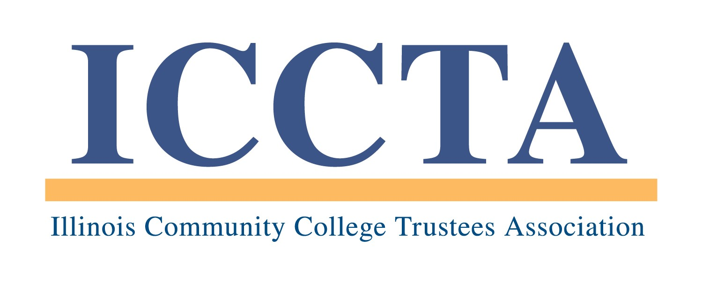

2020 GARY W. DAVIS ETHICAL LEADERSHIP AWARD

The Illinois Community College Trustees Association’s Gary W. Davis Ethical Leadership Award honors individuals who have made an outstanding contribution to the pursuit and support of ethical leadership and decision-making in their fields of work and volunteer service.

Established in 2004, the award recognizes the importance of fostering ethical values systems both within the Illinois community college system and in the larger communities they serve. Special consideration will be given to those nominees whose ethical leadership has positively impacted community colleges or educational access in a local, national or global way.

AWARD GUIDELINES
Each nomination for the ICCTA Gary W. Davis Ethical Leadership Award will be reviewed according to the following criteria:
▪ How has the nominee fostered the following ethical values in his/her professional activities: trustworthiness, respect, responsibility, fairness, compassion, citizenship?
▪ How has the nominee utilized these ethical values in guiding his/her decision-making behavior?
▪ How has the nominee served as an advocate for these ethical values outside his/her field of employment?
▪ How has the nominee positively impacted community colleges or educational access in a local, national or global way?

NOMINATION REQUIREMENTS
Nominations for the ICCTA Gary W. Davis Ethical Leadership Award must be submitted by the board of trustees of an ICCTA member college. Each ICCTA member college is eligible to nominate one individual per year. Posthumous nominations are not eligible for submission.

In order for a nomination to be considered, all of the following items must be included in the nomination packet. The total length must not exceed six (6) one-sided pages:
▪ Letter of support from the college board of trustees
▪ Responses to each award criteria question
▪ Letter of acknowledgment from the nominee
▪ Optional supplemental materials (i.e., resumé, news articles, brochures, photos)

In addition, the nomination must include a narrative statement (not to exceed 150 words) that explains the nominee’s qualifications and is suitable for use in ICCTA publicity materials. The narrative statement is not included in the 6-page nomination packet, but it is required for a nomination to be considered.

★ Failure to follow these guidelines may result in the disqualification of a nomination ★

PROGRAM DEADLINES
All nomination materials must be received by FRIDAY, FEBRUARY 28, 2020. THIS DEADLINE WILL BE STRICTLY ENFORCED. All award nominees will be invited to attend ICCTA's June 5, 2020 awards banquet in Chicago, where the statewide winner will be announced.

All nominations and support materials should be sent to the Illinois Community College Trustees Association, 401 E. Capitol, Suite 200, Springfield, IL 62701-1711. For more information, please contact Kim Villanueva at kvillanueva@communitycolleges.org or 1-800-454-2282.

2020 ICCTA Gary W. Davis Ethical Leadership Award
Nomination Form

Name of award nominee
Community college
Nominee’s mailing address
Telephone # E-mail address

Name of nominator
Community college
Title/position
Nominator’s mailing address
Telephone # E-mail address

To ensure that your awards nomination is processed without delay, please check off the following items before submitting this information:

Nominations Packet -- NO MORE THAN SIX (6) SINGLE-SIDED PAGES may be submitted:
□ Letter of support from the college board of trustees
□ Responses to each award criteria question
□ Letter of acknowledgment from the nominee
□ Optional supplemental materials (i.e., resumé, news articles, brochures, photos)

Also required for consideration (but not included in the 6-page limit):
□ Narrative statement of no more than 150 words
□ Completed nomination form

This nomination form and supporting materials must be received by 5 PM, Friday, February 28, 2020, at the:

Illinois Community College Trustees Association
401 E. Capitol, Suite 200
Springfield, IL 62701-1711
E-MAIL: iccta@communitycolleges.org

▪ For more information, contact Kim Villanueva at kvillanueva@communitycolleges.org or 1-800-454-2282 ▪

