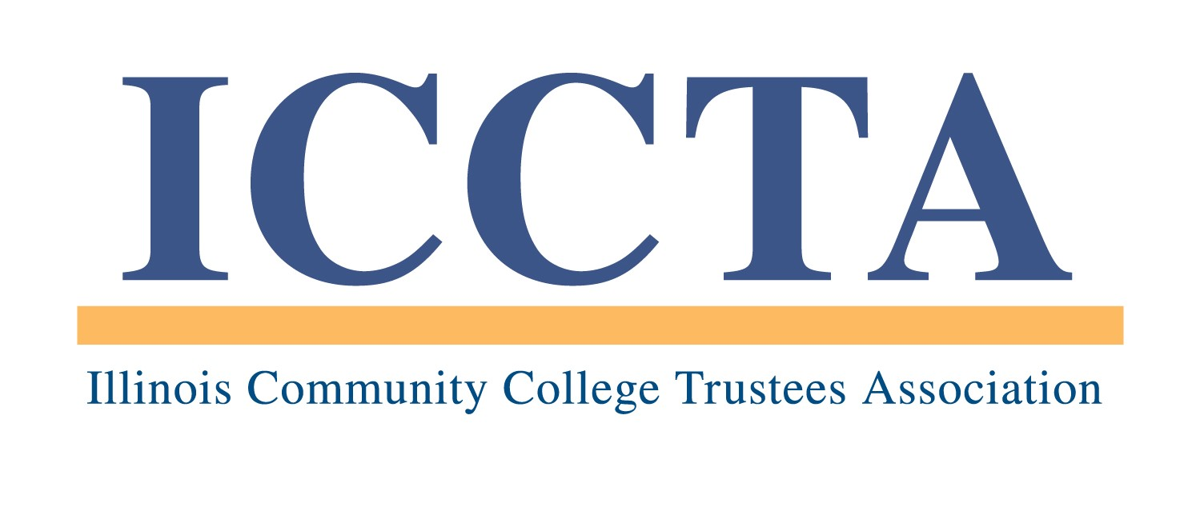

2020 LIFELONG LEARNING AWARD

The Illinois Community College Trustees Association's Lifelong Learning Award celebrates the accomplishments of Illinois’ community college students over the age of 50 who have used their community college as a resource on multiple occasions.

AWARD CRITERIA
Each nomination for the ICCTA Lifelong Learning Award will be reviewed according to the following criteria:
▪ Current enrollment in a credit course at an Illinois public community college after age 50
▪ Completion of at least six (6) credit hours at an Illinois public community college
▪ Demonstrated lifetime commitment to professional development and/or personal enrichment
▪ New abilities or experiences gained by attending a community college
▪ Continued interest in and support of community colleges (i.e., mentorships, participation in student activities)
▪ Future aspirations

NOMINATION REQUIREMENTS
Nominations for the ICCTA Lifelong Learning Award must be submitted by the board of trustees of an ICCTA member college. Each ICCTA member college is eligible to nominate one individual each year. Currently serving trustees and presidents are not eligible for nomination. Posthumous nominations are not eligible for submission.

In order for a nomination to be considered, all of the following items must be included in the nomination packet. The total length must not exceed six (6) single-sided pages:

▪ Letter of support from the college board of trustees
▪ Responses to each award criteria question
▪ Self-statement of 250 words or less describing how the nominee's life has been shaped by a community
college education
▪ Optional supplemental materials (i.e., resumé, news articles, brochures, photos)

In addition, the nomination must include a narrative statement (not to exceed 150 words) that explains the nominee’s qualifications and is suitable for use in ICCTA publicity materials. The narrative statement is not included in the 6-page nomination packet, but it is required for a nomination to be considered.

★ Failure to follow these guidelines will result in the disqualification of a nomination ★

Because the names of many deserving nominees are received each year, boards of trustees are encouraged to re-submit the names and qualifications of former nominees for consideration.

PROGRAM DEADLINES
All nomination materials must be received by 5 PM, Friday, April 3, 2020. THIS DEADLINE WILL BE STRICTLY ENFORCED. All award nominees will be invited to attend ICCTA's June 5, 2020 awards banquet in Chicago, where the statewide winner will be announced.

All nominations and support materials should be sent to the Illinois Community College Trustees Association, 401 E. Capitol, Suite 200, Springfield, IL 62701-1711. For more information, please contact Kim Villanueva at kvillanueva@communitycolleges.org or 1-800-454-2282.

2020 Lifelong Learning Award
Nomination Form

Name of award nominee
Community college
Nominee’s mailing address
Telephone # E-mail address

Name of nominator
Community college
Title/position
Nominator’s mailing address
Telephone # E-mail address

To ensure that your awards nomination is processed without delay, please check off the following items before submitting this information:

Nominations Packet -- NO MORE THAN SIX (6) SINGLE-SIDED PAGES may be submitted:
□ Letter of support from the college board of trustees
□ Responses to each award criteria question
□ Self-statement of 250 words or less describing how the nominee's life has been shaped by
a community college education
□ Optional supplemental materials (i.e., resumé, news articles, brochures, photos)

Also required for consideration (but not included in the 6-page limit):
□ Narrative statement of no more than 150 words
□ Completed nomination form

This nomination form and supporting materials must be received by 5 PM, Friday, April 3, 2020, at the:

Illinois Community College Trustees Association
401 E. Capitol, Suite 200
Springfield, IL 62701-1711
E-MAIL: iccta@communitycolleges.org

▪ For more information, contact Kim Villanueva at kvillanueva@communitycolleges.org or 1-800-454-2282 ▪

