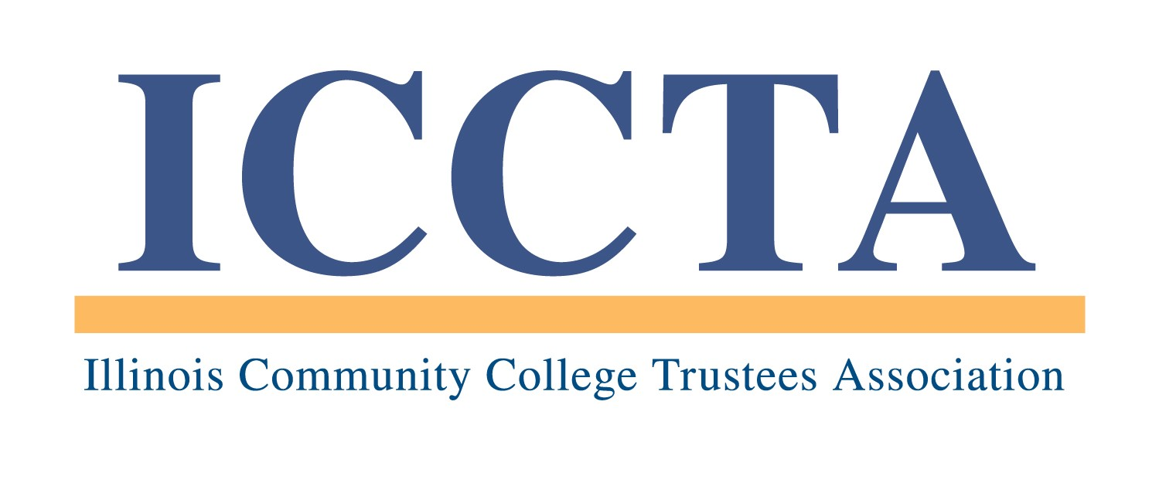

2020 GANDHI / KING PEACE SCHOLARSHIP

The Illinois Community College Trustees Association's Gandhi / King Peace Scholarship provides a $1,000 scholarship to the student who best articulates the peaceful messages of Mahatma Gandhi and Dr. Martin Luther King, Jr. This award has been endowed by Oakton Community College trustee Jody Wadhwa and the Oakton Education Foundation.

GUIDELINES
All currently enrolled students at ICCTA member colleges are eligible to participate in the Gandhi / King Peace Scholarship competition. Each college may submit one entry per academic year.

Participants must address the Writing Prompt described below. Each submission must be no longer than 500 words in length, typed single-spaced in business-letter format, and accompanied by a completed Entry Form.

All entries will be judged on the basis of the following criteria:
• Demonstrated understanding of the significance of the work of Gandhi and King
• Content, strength and persuasiveness of argument
• Personal goals and involvement in peacebuilding efforts
• Writing style, clarity of expression, and correct grammar and punctuation

★ Failure to follow these rules will result in the disqualification of an entry ★

WRITING PROMPT
Both Mahatma Gandhi and Dr. Martin Luther King, Jr., advocated for nonviolence as the way to confront the hate and discrimination that so often accompanies the disrespect of other human beings. The work and words of Gandhi and King are both an example and a road map for the way forward for our country. As a community college student, outline a plan that will educate the members of your college community about the scope of the problem and the elements of and rationale for a nonviolent response. In the description of your plan, draw on the lives and writings of Gandhi and King.

CONTEST DEADLINES
All entries must be received by 5 PM, Friday, March 27, 2020. The winner of the Gandhi / King Peace Scholarship competition will receive a $1,000 cash stipend for educational expenses during the fall 2020 semester. In addition, ICCTA will invite the winner to attend the association's June 5, 2020 awards banquet in Chicago.

To submit an entry for the Gandhi / King Peace Scholarship competition, please send your essay and a completed Entry Form (signed by the appropriate contact person at your local community college) to:

Illinois Community College Trustees Association
401 E. Capitol, Suite 200
Springfield, IL 62701-1711
E-MAIL: iccta@communitycolleges.org

▪ For more information, please contact Kim Villanueva at 1-800-454-2282, ext. 1 ▪

2020 ICCTA Gandhi / King Peace Scholarship
Nomination Form

Name of Student Entrant

Home Address

City/State/Zip

Telephone E-mail Address

Name of College

Contact Person

Title

Telephone E-mail Address

To be eligible for the 2020 Gandhi / King Peace Scholarship, your essay and this completed entry form must be received by 5 PM, Friday, March 27, 2020, at the:

Illinois Community College Trustees Association
401 E. Capitol, Suite 200
Springfield, IL 62701-1711
E-MAIL: iccta@communitycolleges.org

▪ For more information, contact Kim Villanueva at kvillanueva@communitycolleges.org or 1-800-454-2282 ▪

